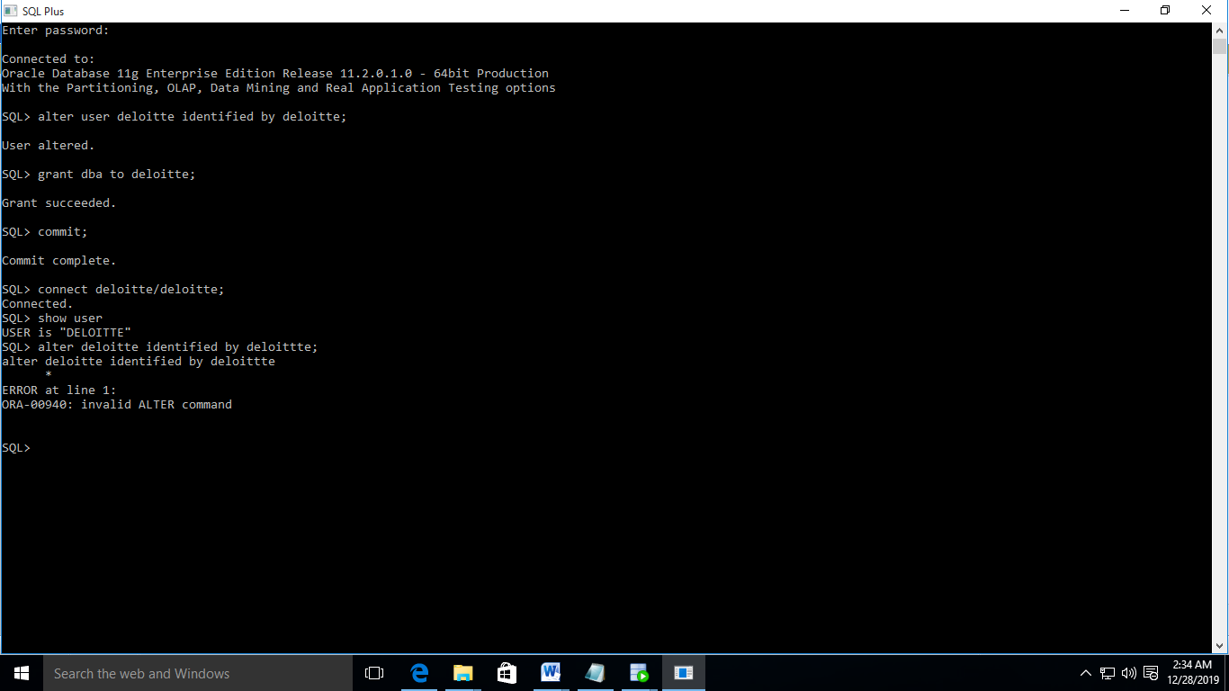

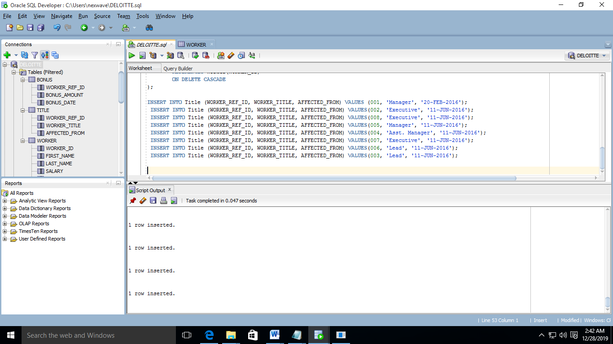

4.Write An SQL Query To Fetch “FIRST_NAME” From Worker Table Using The Alias Name As <WORKER_NAME>.

Ans. Select first_name||last_name as worker_name

from worker;

1. Write An SQL Query To Fetch “FIRST_NAME” From Worker Table In Upper Case.

Ans. Select upper(first_name)

From worker;

1. Write An SQL Query To Fetch Unique Values Of DEPARTMENT From Worker Table.

Ans. select unique department

from worker;

1. Write An SQL Query To Find The Position Of The Alphabet (‘A’) In The First Name Column ‘Amitabh’ From Worker Table.

select instr(first_name,'A')

from worker

where first_name='Amitabh';

1. Write An SQL Query To Print The First Three Characters Of  FIRST_NAME From Worker Table.

Ans. select substr(first_name,0,3)

from worker;

1. Write An SQL Query To Print The FIRST_NAME From Worker Table After Removing White Spaces From The Right Side.

Ans. select rtrim (first_name)

from worker;

1. Write An SQL Query To Print The DEPARTMENT From Worker Table After Removing White Spaces From The Left Side.

Asn. select ltrim (department)

from worker;

1. Write An SQL Query That Fetches The Unique Values Of DEPARTMENT From Worker Table And Prints Its Length.

Ans. select length(unique(department) )

from worker;

12.Write An SQL Query To Print The FIRST_NAME From Worker Table After Replacing ‘A’ With ‘a’.

Ans. select replace(first_name,'A','a')

from worker;

1. Write An SQL Query To Print The FIRST_NAME And LAST_NAME From Worker Table Into A Single Column COMPLETE_NAME. A Space Char Should Separate Them.

select first_name||' '||last_name as complete_name

from worker;

1. Write An SQL Query To Print All Worker Details From The Worker Table Order By FIRST_NAME Ascending.

Select *

From worker

Order by first_name asc;

1. Write An SQL Query To Print All Worker Details From The Worker Table Order By FIRST_NAME Ascending And DEPARTMENT Descending.

Ans. Select *

From worker

Order by first_name asc,department dsc;

1. Write An SQL Query To Print Details For Workers With The First Name As “Vipul” And “Satish” From Worker Table.

Ans. select *

from worker

where first_name='Vipul'

or first_name='Satish';

1. Write An SQL Query To Print Details Of Workers Excluding First Names, “Vipul” And “Satish” From Worker Table.

Ans. select *

from worker

where first_name not'Vipul'

or first_name not 'Satish';

1. Write An SQL Query To Print Details Of Workers With DEPARTMENT Name As “Admin”.

Ans. select *

from worker

where department= 'Admin';

1. Write An SQL Query To Print Details Of The Workers Whose FIRST_NAME Contains ‘A’.

Ans. select *

from worker

where First_name like '%A%';

1. .Write An SQL Query To Print Details Of The Workers Whose FIRST_NAME Ends With ‘A’.

Ans. select *

from worker

where First_name like '%A';

1. Write An SQL Query To Print Details Of The Workers Whose FIRST_NAME Ends With ‘H’ And Contains Six Alphabets.

Ans. select first_name

from worker

where first_name like '%H' and

length(first_name)=6;

1. Start the executable section with the BEGIN keyword and include a SELECT statement to retrieve the maximum department_id from the departments table.

Ans. set serveroutput on

BEGIN

select max(department_id) into v_max_deptno from departments;

1. Write a PL/SQL block to show a reserved word can be used as a user-define identifier.

Ans. DECLARE

"WORLD" varchar2(20) := 'world';

"DECLARE" varchar2(20) := 'declare';

BEGIN

DBMS_Output.Put_Line(World);

DBMS_Output.Put_Line(DECLARE);

end;

/

1. Write PL/SQL blocks to show the scope and visibility of local and global identifiers.

Ans. DECLARE

var_a INTEGER;

var_b REAL; -- Scope of var_b is REAL

BEGIN

var_a:=5;

var_b:=10.25;

-- Visible: var_a (INTEGER), var_b (REAL)

DBMS_OUTPUT.PUT_LINE('In the Outer Block');

DBMS_OUTPUT.PUT_LINE('var_a = ' || var_a);

DBMS_OUTPUT.PUT_LINE('var_b = ' || var_b);

1. Write a PL/SQL block to adjust the salary of the employee whose ID 122.

Ans.

DECLARE

salary_of_emp NUMBER(8,2);

PROCEDURE approx_salary (

emp NUMBER,

empsal IN OUT NUMBER,

addless NUMBER

) IS

BEGIN

empsal := empsal + addless;

END;

BEGIN

SELECT salary INTO salary_of_emp

FROM employees

WHERE employee_id = 122;

DBMS_OUTPUT.PUT_LINE

('Before invoking procedure, salary_of_emp: ' || salary_of_emp);

approx_salary (100, salary_of_emp, 1000);

DBMS_OUTPUT.PUT_LINE

('After invoking procedure, salary_of_emp: ' || salary_of_emp);

END;

/